**Faculty of Engineering, Environment and Computing**

**5031 CEM 3D Modelling**

**TIAGO PATRÍCIO**

**Coursework 1 - Report**

**Concept Generation**

Bearing in mind the objective of creating two 3D models and appropriate environments and textures in a 3D scene, I should be using Blender as the most sensible resource, as previously learnt during the course.

I thought I should choose two models that would be meaningful to me and at the same time represented a decent challenge as a design piece.

For the first model, I just realised I didn’t need to go any further, as I had it under my hands - a computer keyboard. This is really one of the objects I use most and I figured it would be a bit of a challenge, while also allowing to put in practice some of the available techniques.

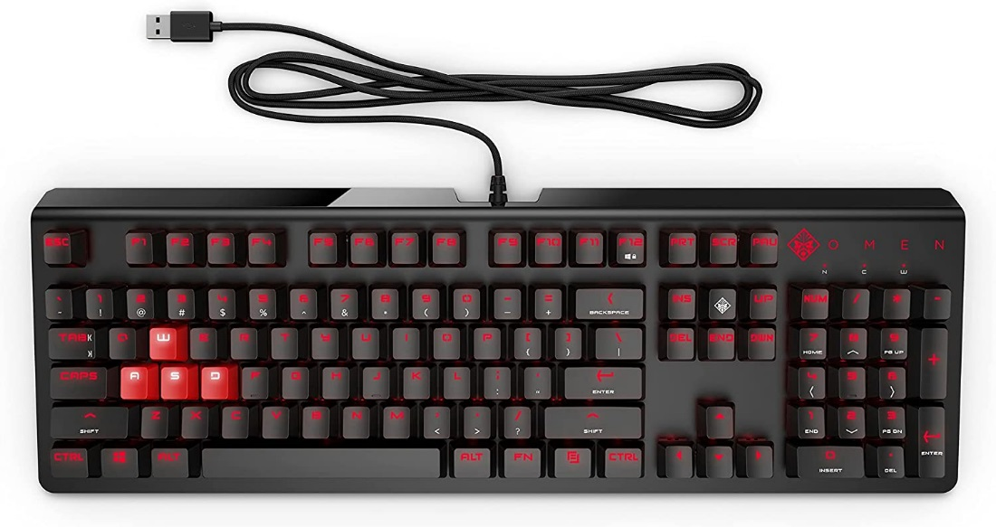

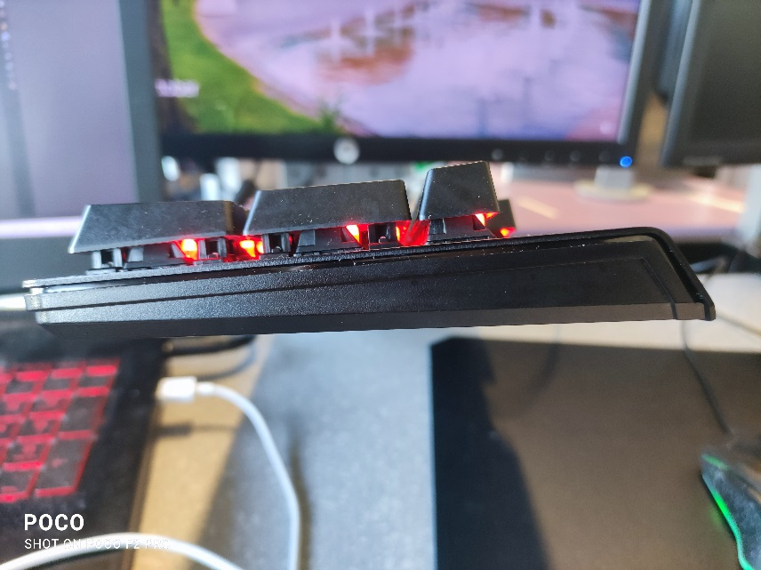

After creating the keyboard model, I decided to challenge myself a bit more.

I thought I should look for a model that could represent a more cutting-edge engineering or design development, and this would naturally involve looking out of my room. After careful consideration, I decided to make the 3D model of an airplane, since one brought me to the UK and I remembered I am always fascinated, looking at those perfect lines when I have a chance to be next to one. Which plane is more iconic within the passenger models? I guess the Boeing 747, also called “Jumbo”, with that exclusive first-class cabin on top, so I searched some images and detailed components to create a model as realistic as possible.

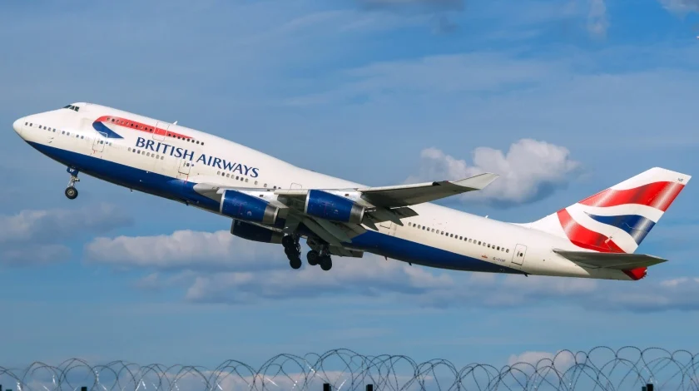

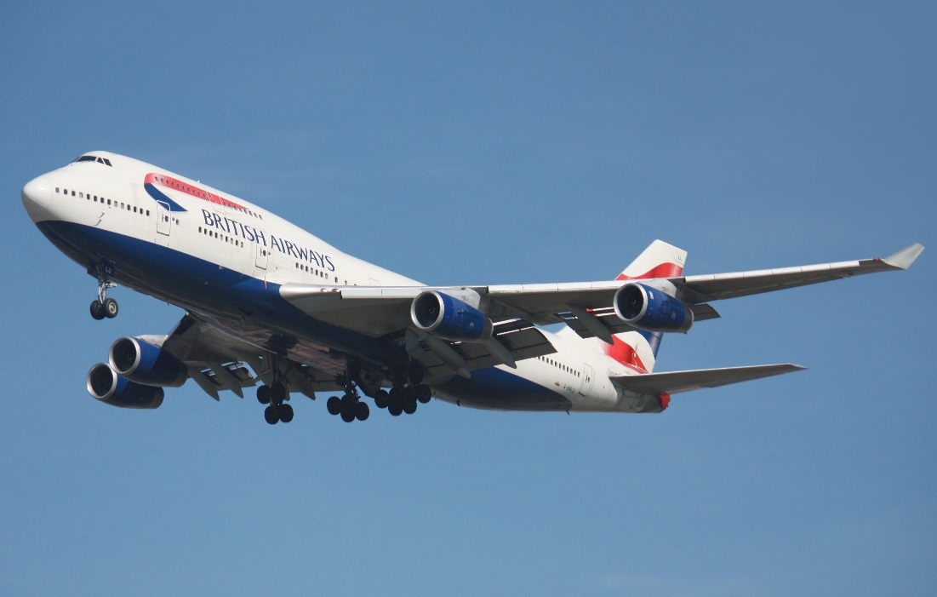

The four-engined Boeing 747 was designed to be the safest airliner so far built. Redundancy was in place for systems such as hydraulics, where a backup was available should the main system fail. There were dual control surfaces to enable the continued control of the aircraft should any of the surfaces fail. There were four main landing gear bogies each with four wheels. This was not only to spread the weight of the aircraft more evenly, but the 747 was capable of landing on two opposing bogies if necessary.

https://modernairliners.com/boeing-747-jumbo/boeing-747-specs/

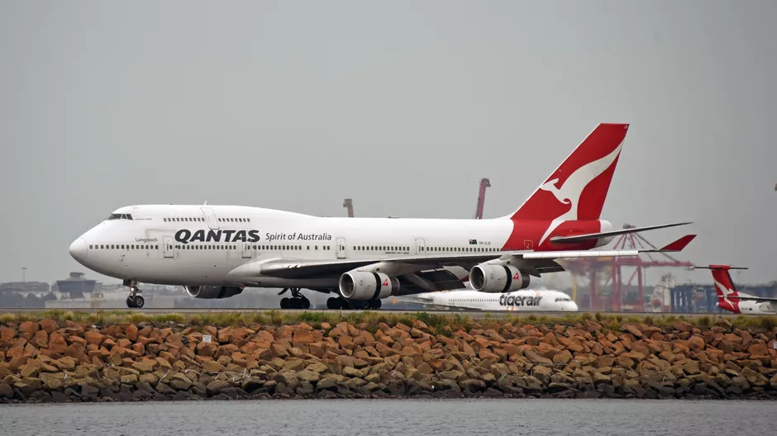

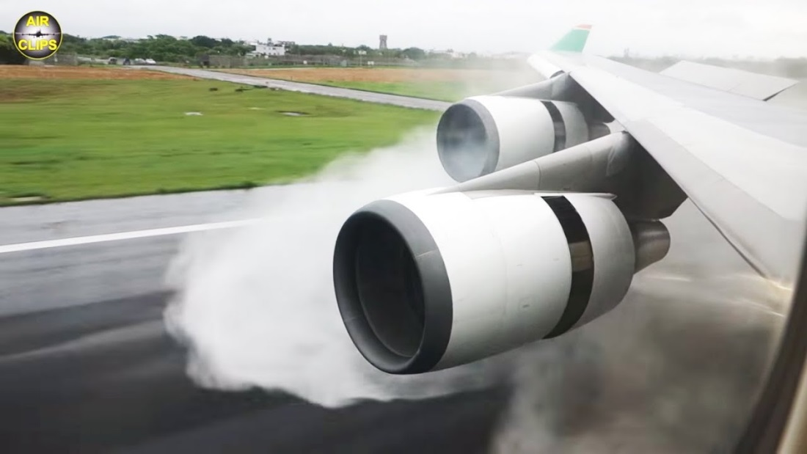

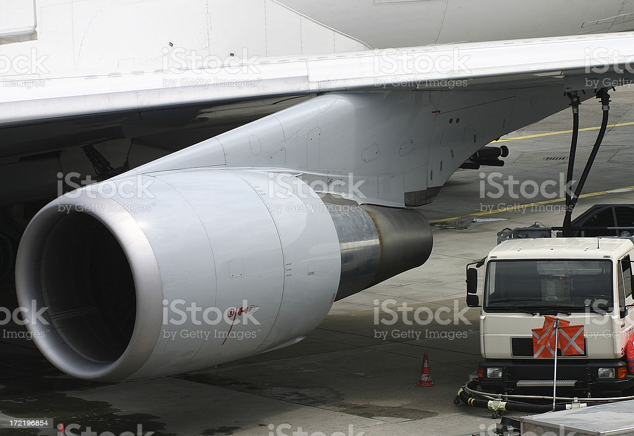

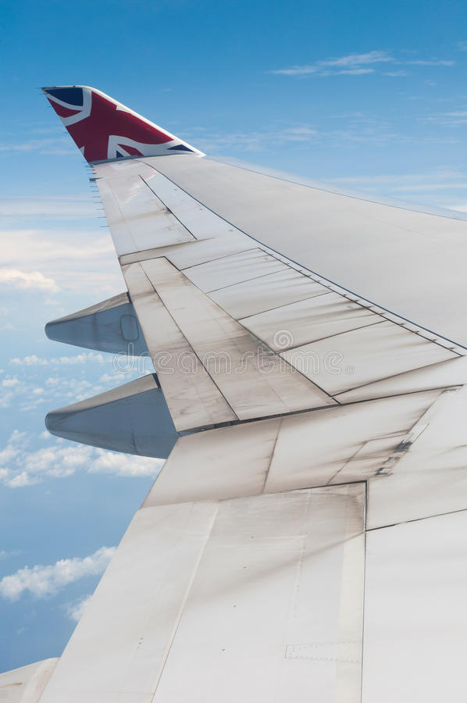

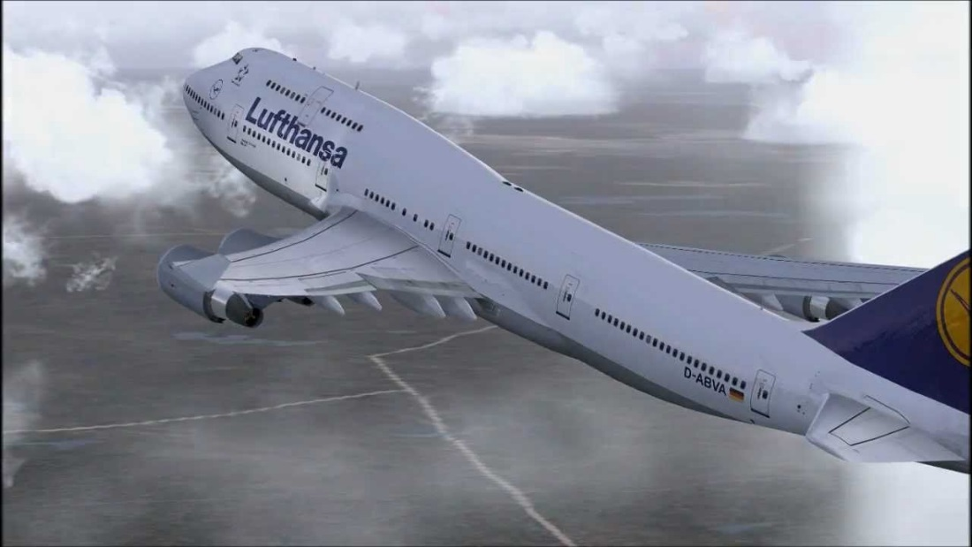

Blueprints used to project the three-dimensional planes, against which the dimensions of the object (Boeing 747) would align.

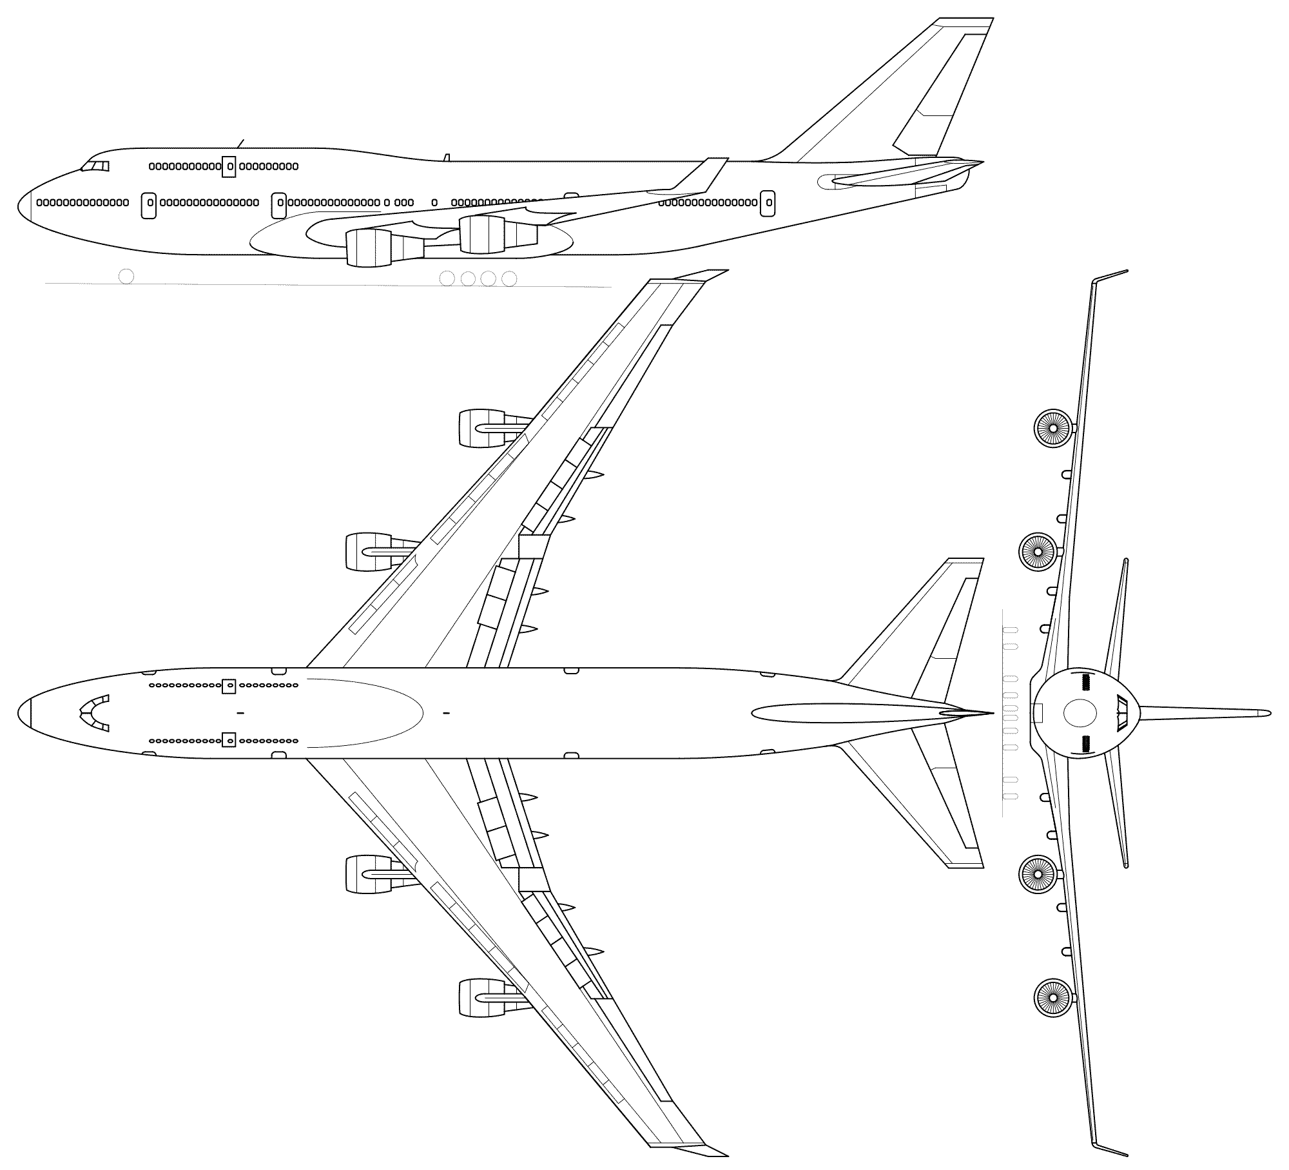

**Evidence of 3D Modelling**

Using Blender, I started creating the keyboard model as soon as I got the idea, and I do not have much evidence to show, but this was built from scratch, based on my own keyboard.

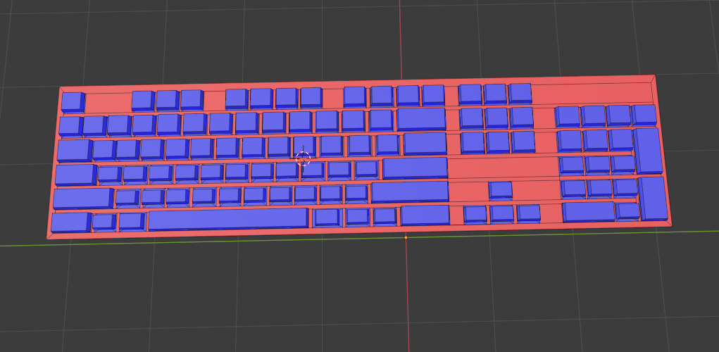

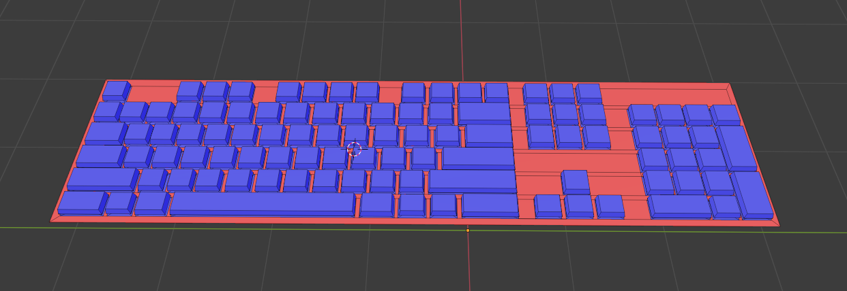

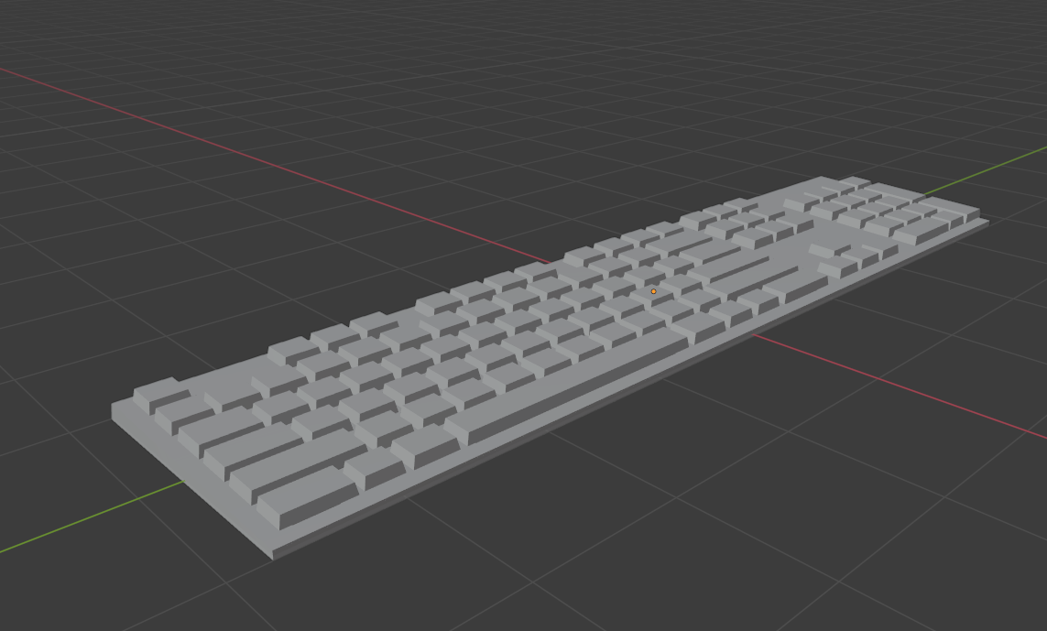

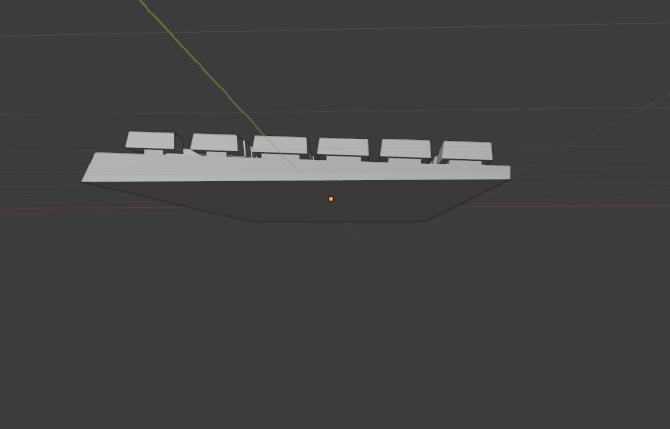

I anticipated that the main model I should focus on, requiring a greater combination of techniques, would be the airplane, therefore this was the one on which I gathered more evidence of the modelling process.

Indeed, the plane was a bit more complicated, also due to my inexperience, I had to re-start the model 3 Times, until I managed to get the right representation.

On the first approach, in order to give it what I thought would be an in-depth detail, I started creating the airplane model vertex by vertex, which took too much of my time, but since it started to get shape and it looked good, I was not so worried.

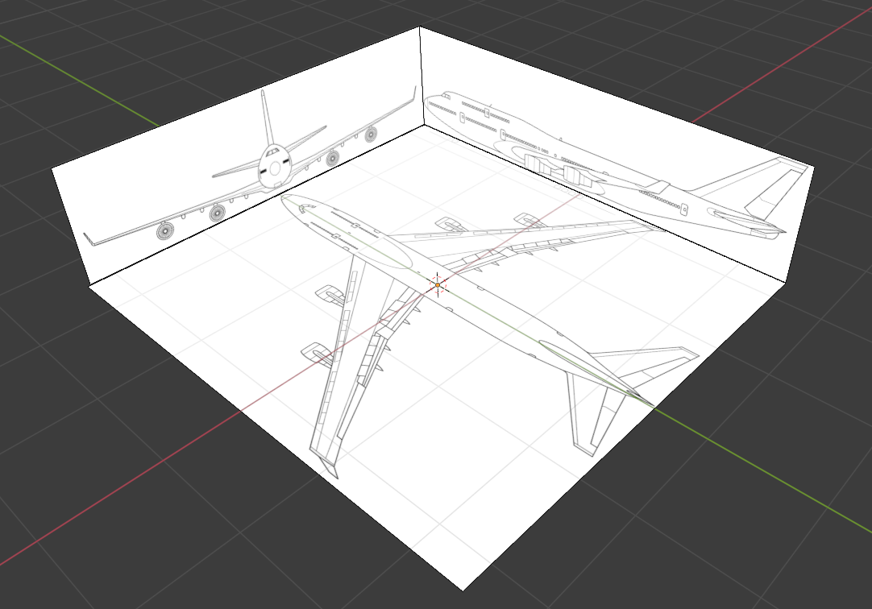

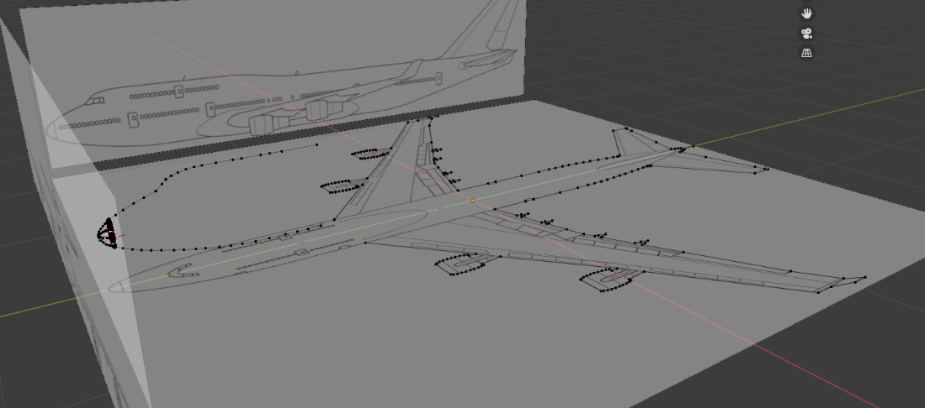

It was only when I reached the stage of adding faces to the model and it started getting weird shapes and everything was out of place that I decided to give up on this idea.

The second attempt was after talking to some of my colleagues and researching a bit more about 3D modelling. I decided to start over, but this time with a cylinder, an available solid within Blender, as the best starting point to try and mould an airplane shape.

I scaled the cylinder to fit perfectly with the reference images on every position and shaped its form easily using loop-cuts, which made me realise how much time I had lost before and how difficult it would have been for an inexperienced student to get anywhere near a realistic model.

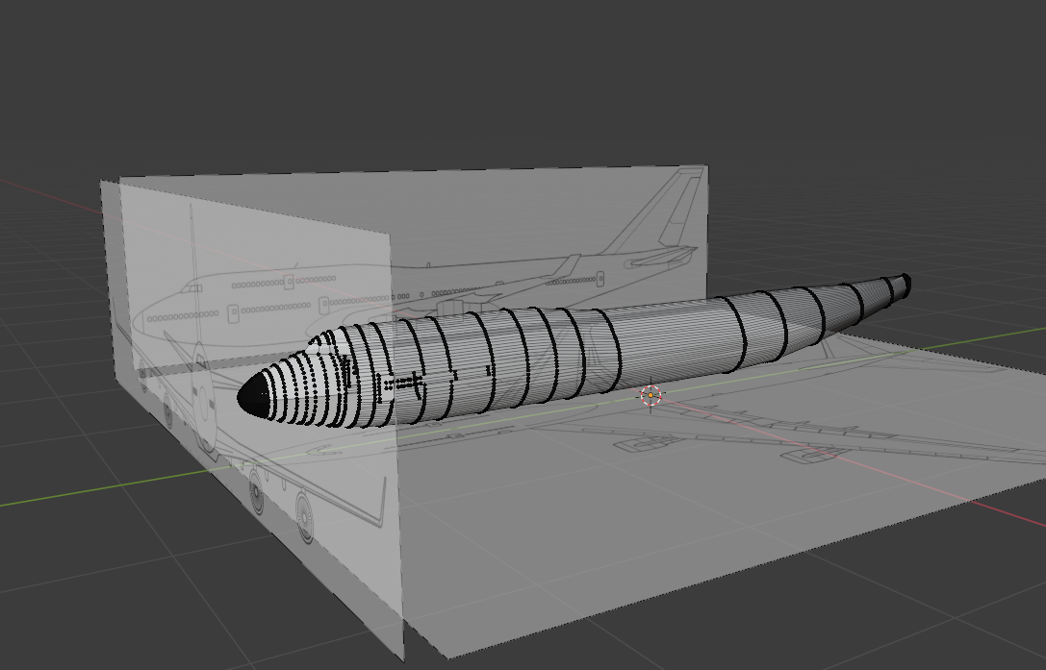

Anyway, once again I exaggerated with the number of loop-cuts and vertexes that I developed from the original solid, and ended-up dropping this model.

Moving on to my third and final attempt, I simplified my previous model with less loop-cuts and started using the mirror modifier tool, to help me create the body and wings of the model with less effort.

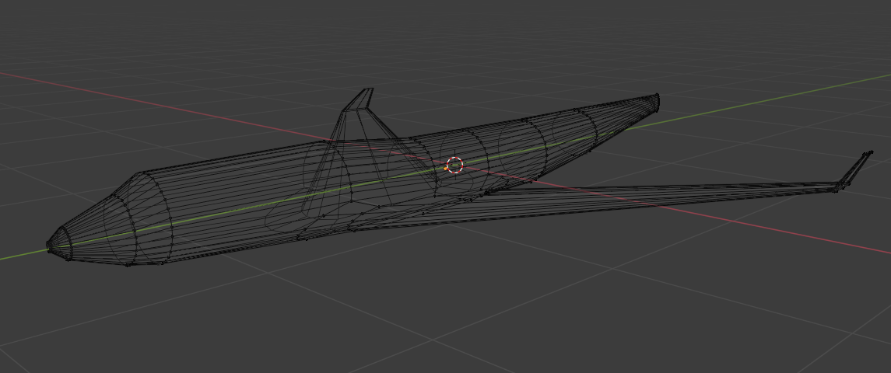

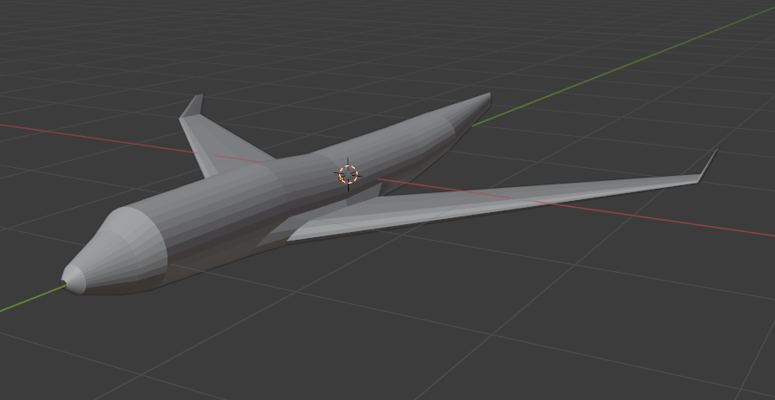

**3D mesh optimisation**

To make my model airplane look more like a real airplane, I added a subdivision surface modifier and refined my model by adding stabilizers to the tail as well as a windshield on the pilot's cockpit.

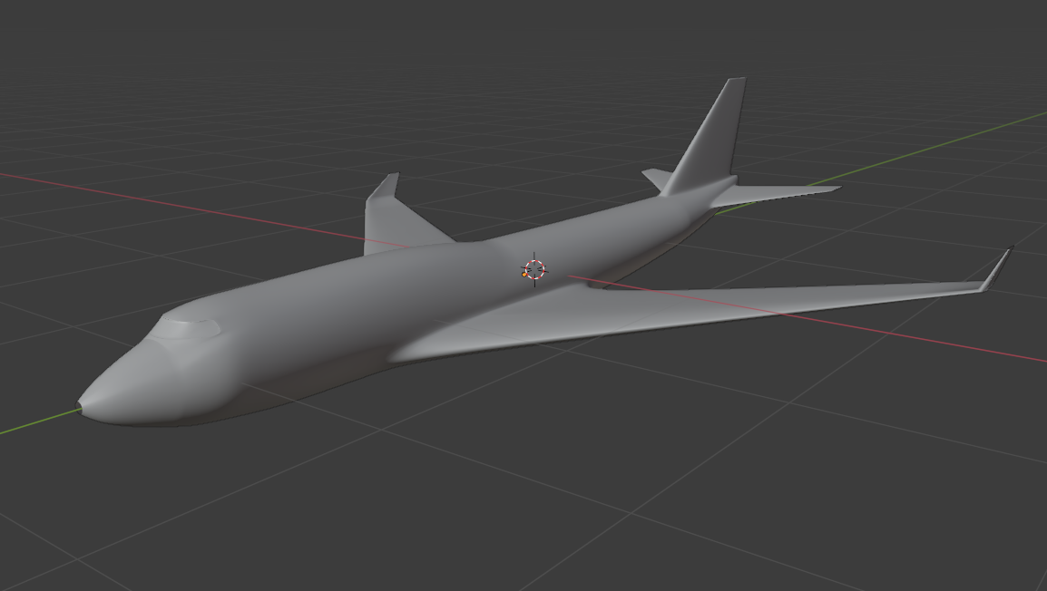

**Visual evidence of modelling workflow**

I then proceeded to add the jet engines and other detailed elements to the airplane

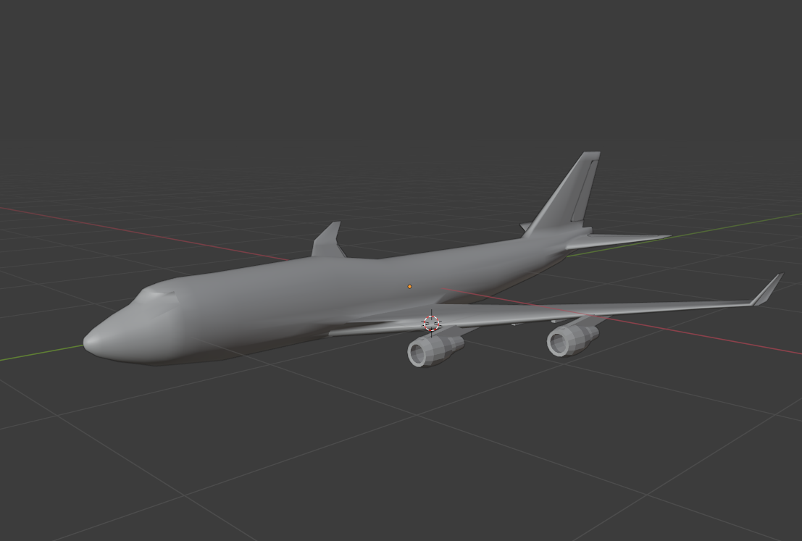

In order to create a nicely detailed look on the distinct parts of the airplane I creased some of the parts and seam marked others, preparing for the UV unwrapping.

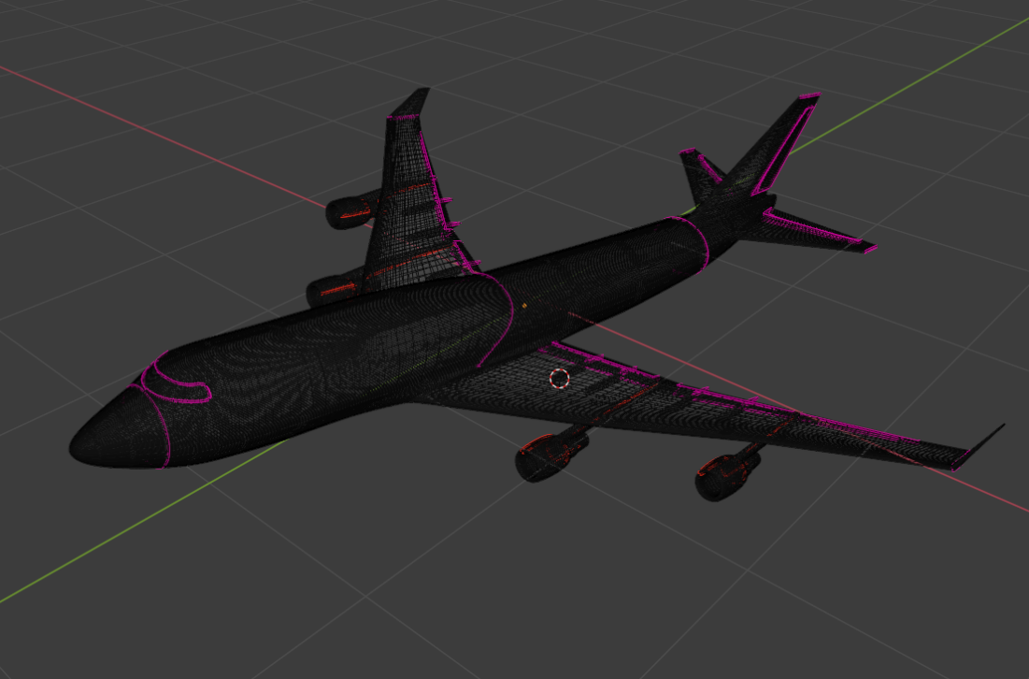

**UV Unwrapping and Texture Creation**

Due to the amount of detail put on the plane I could not smart UV unwrap it as I did in my initial stages of modelling. This is where my research came in handy as I used “project from view” to get the UV map done and then transfer it to Photoshop to create some textures for the windows and doors.

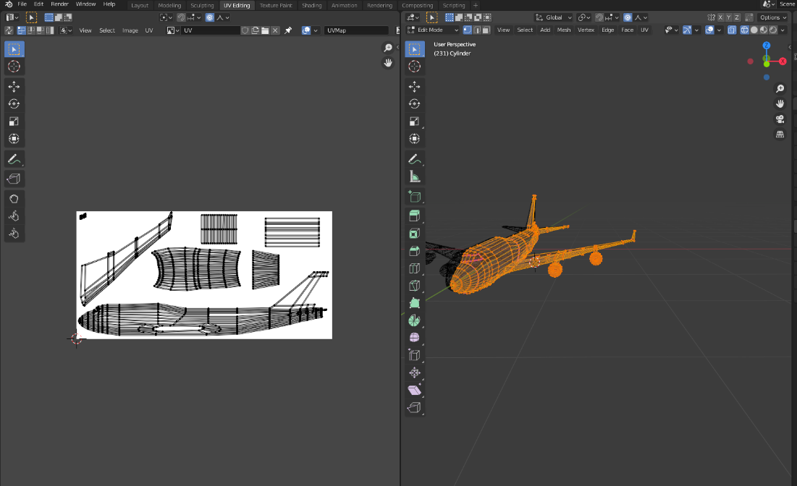

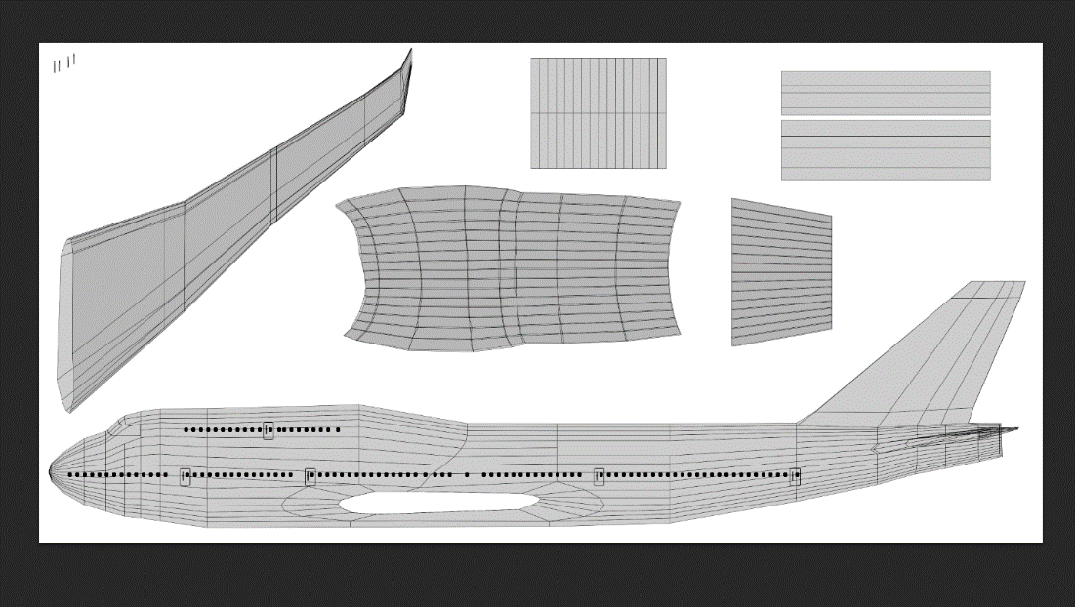

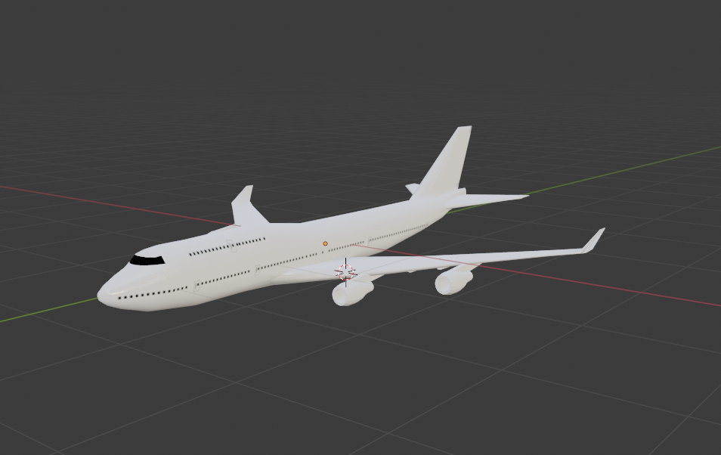

To import and create more detail on the windows and doors, I used the UV Editing workspace, on the shader editor with the nodes help I was able to get a nice-looking texture of everything engraved on the plane surfaces.

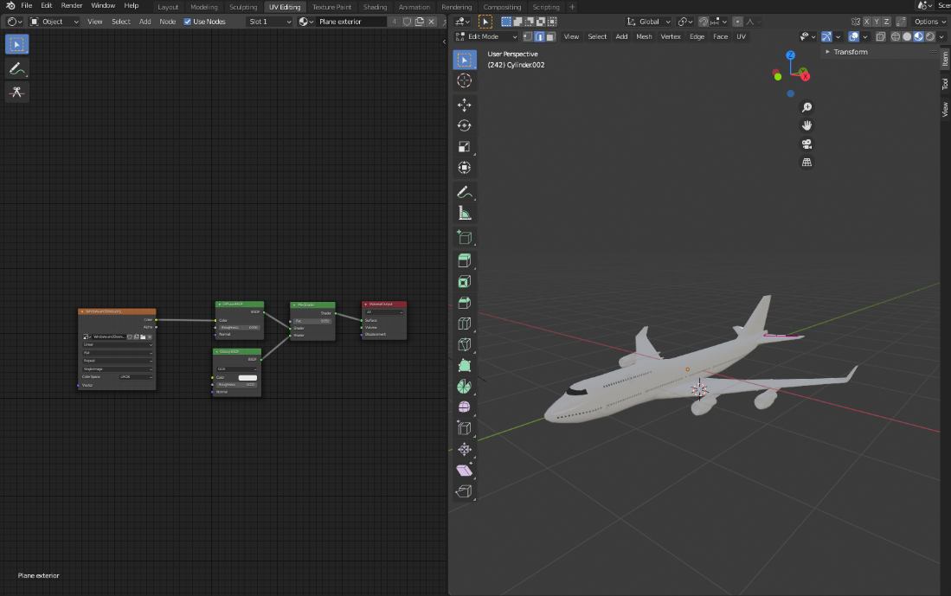

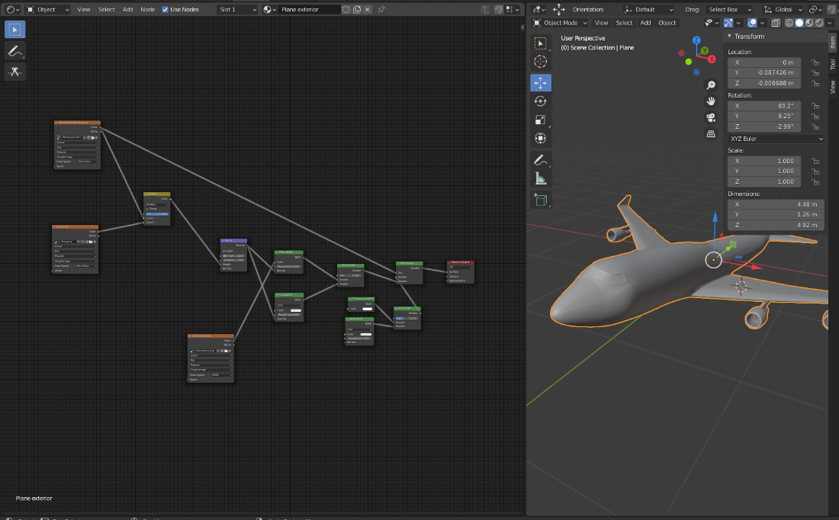

Once that was done, it was time to paint the plane which led me back to Photoshop. By painting over the UV map, I produced a great design which I think looked really cool on the plane as well as adding some other bits of detail with black lines to the wings and engines of the plane.

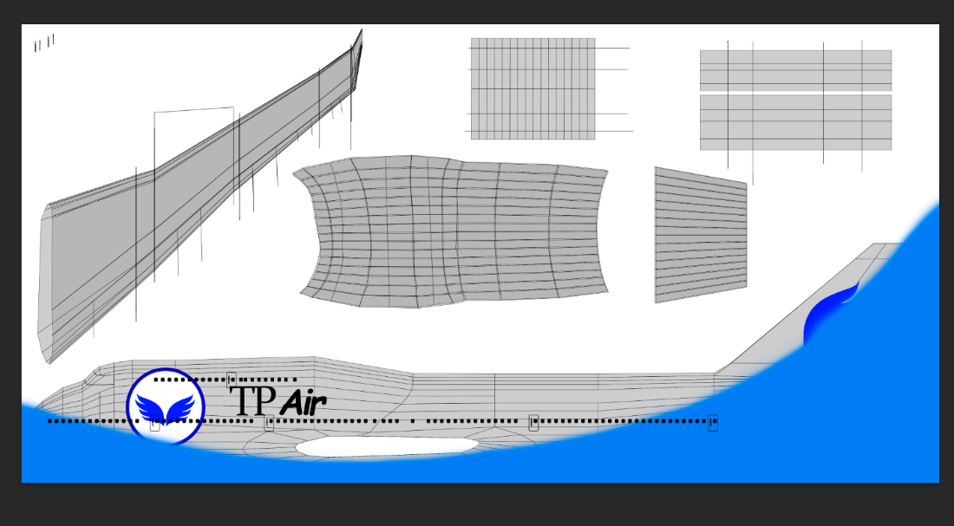

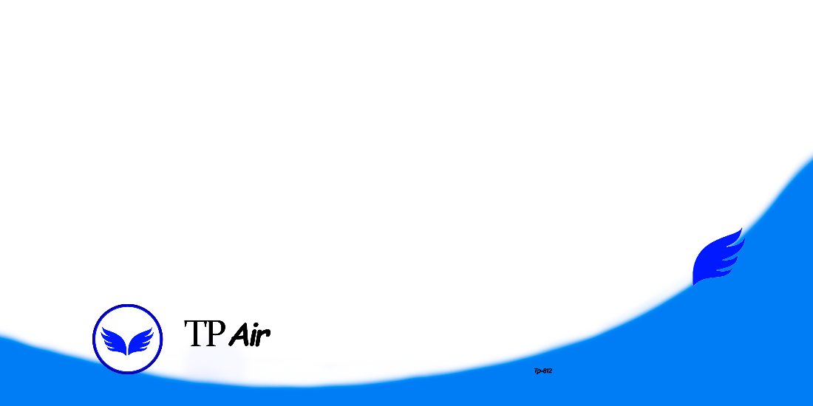

After exporting the final painting, importing it to the plane and changing the colour of the other parts using materials and shading them, my texture was complete.

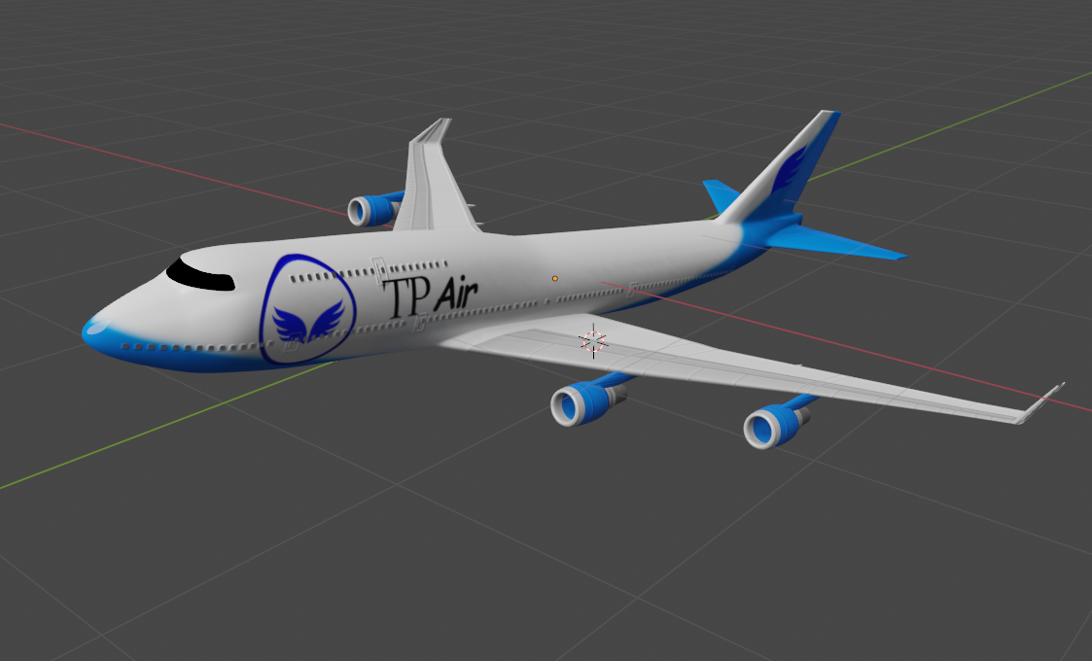

**Render Setup**

The only thing left was to render an animation (separate file) and an image of the plane. I setup a camera and added some sun lighting as well as a background image to get this amazing result.

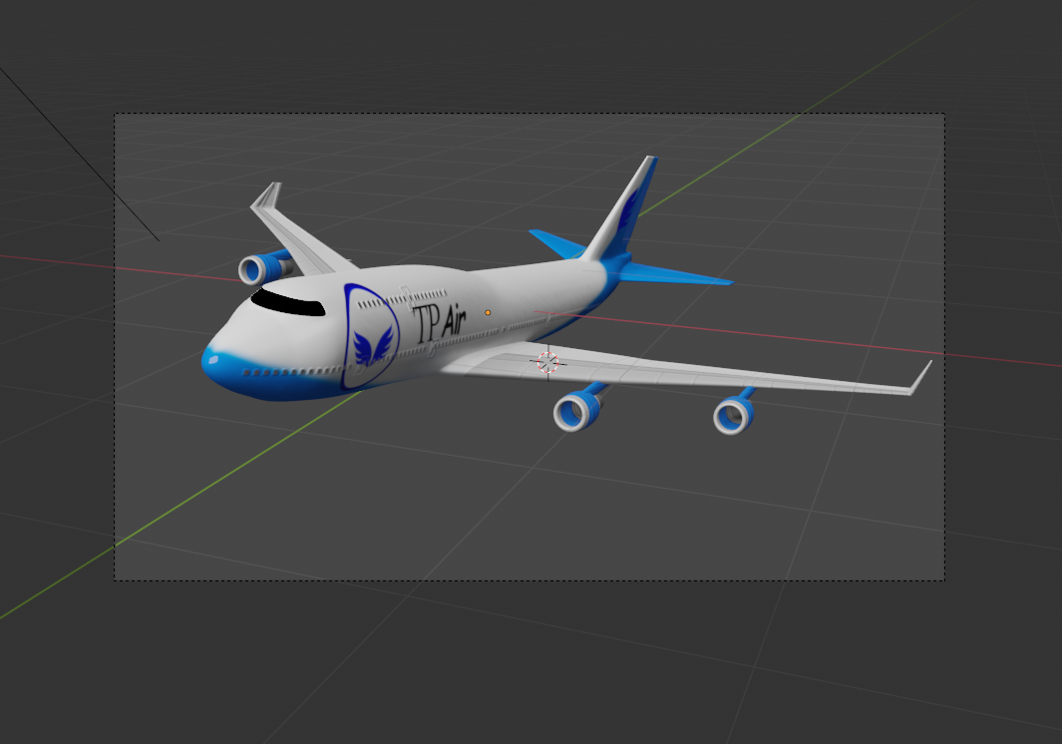

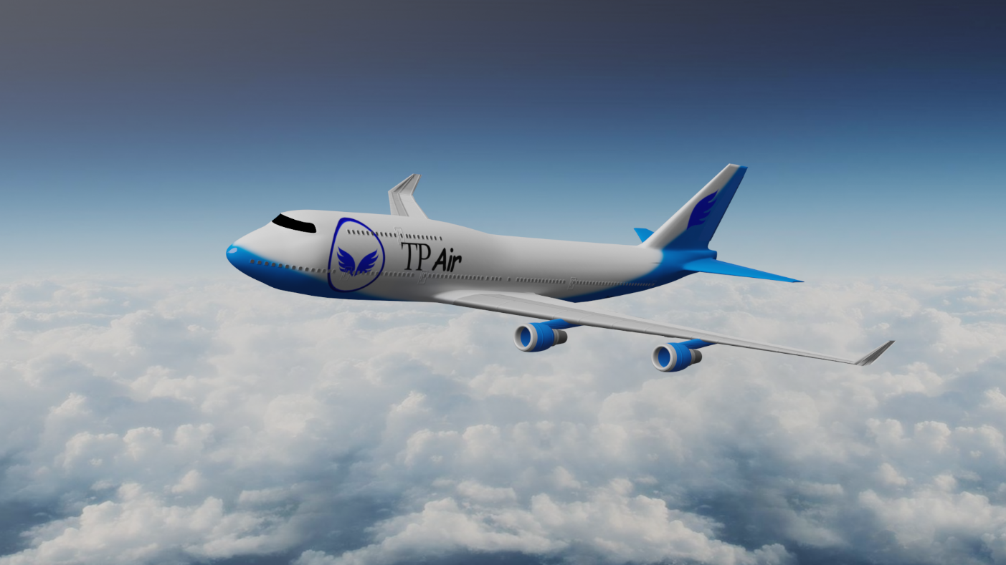

**Critical Reflection**

This project helped me to use my capabilities to the limit at this level and achieve some new insights regarding 3D modelling.

It was a different and hard project to make, but even with all the setbacks, I focused on finishing it and with some perseverance I loved the way it turned out in the end.

Of course, much of the time invested on the project was spent going through some mistakes, resulting from wrong approaches, which made me redo my work several times, but I certainly learned with these errors, and this way I can grow as a 3D modeller, which I am sure will keep growing.

If I had more time now, I would try my best to finish the other model as well and improve the details on the plane since the more detail a model shows, closer to the real thing, the greater It is.